INFORMATION FOR REGISTERING ON THE NEW GAMEDAY DATABASE
We have a new system for 2021-2022 season. The following is the process.
All centres that have been approved for opening will be available on our website. https://lansw.com.au/find-your-centre
Click the centre and the centres details will open if approved. Click the register here button and below will show. You will need to sign up and set your own password.

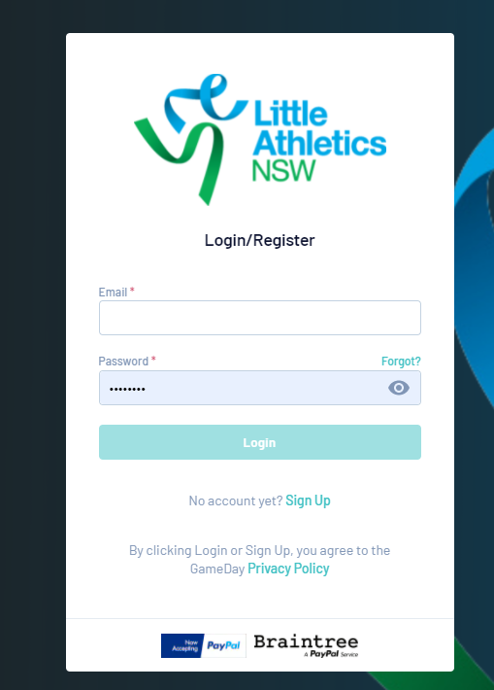

- First page if no linked members to the email address select new participant. This should be the child’s name, with parents’ email and phone number.
- You will then be required to select the child you are registering
- You must select only 1 member type for each child. See details below

CORRECT PROCESS
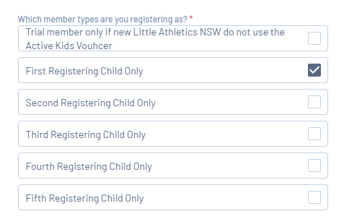
INCORRECT PROCESS
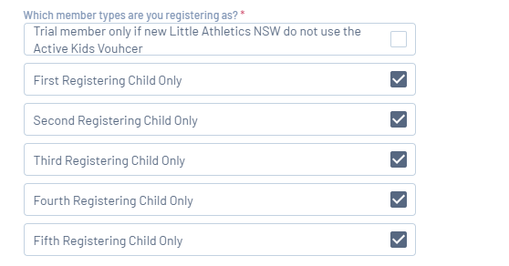
- Next page will have both LANSW and centre fee, except for trials as it will only be the centres. Do not continue if both are not display and contact centre or admin@lansw.com.au

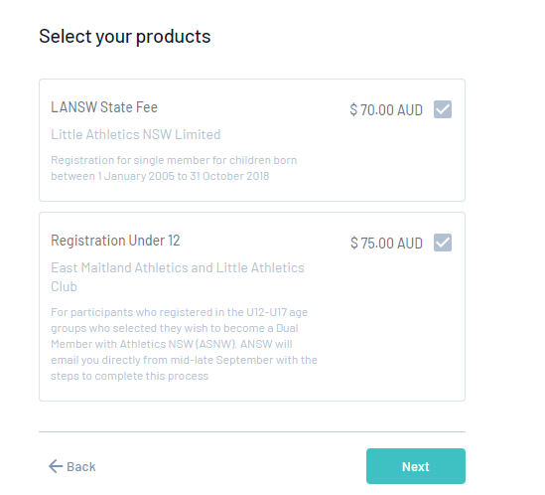

- You will then be required to complete address and questions.
- This year new members will be given the option to upload proof of age or show to the centre.

- Next page will show the summary, this will have both fees and any merchandise if applicable.

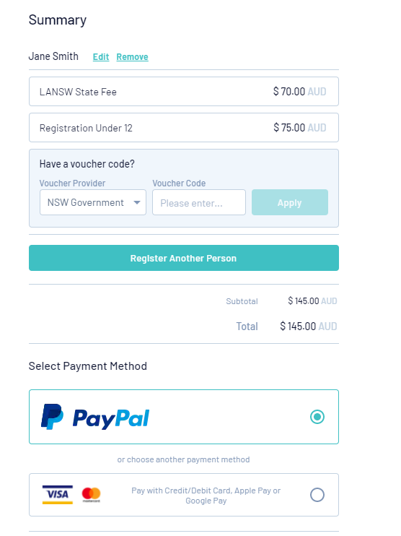

- Add your Active Kids Voucher and click on apply. It will then deduct the $100 from the payment. Voucher Provider is the NSW Government as displayed.
- If adding another child click the register another person.
- You must then select the appropriate 2nd child.
- If a centre gives a discount this will be display on the next page.
- You can repeat for each child and make the payment.
- Remember to only select one member type for each child
Some centres will have merchandise or parent duties, which are not mandatory, so you will be required to tick the box.
If merchandise is selected there will be a question to add the sizes.
If unsure of the process, please speak with your centre or phone our office 9633 4511 or email admin@lansw.com.au

