201 Clovelly Road Randwick. NSW 2031 randwick@runnersshop.com.au 93158711
https://runnersshop.com.au/

To SELAC Members
Hello there!
The 2020/2021 Little Athletics season has begun !
We are the Runners Shop Randwick located at 201 Clovelly Road, Randwick.
Originally Talays Runners Shop of Randwick. We have supported Athletics since the late ‘70’s.
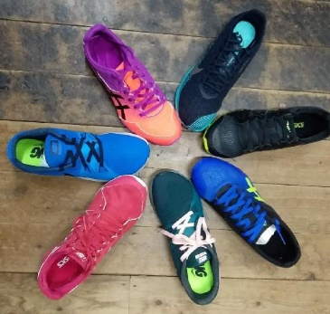
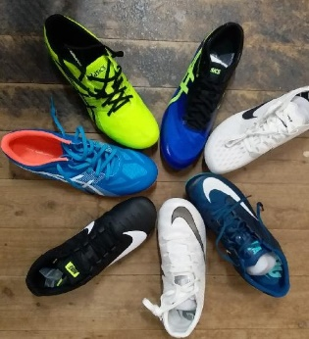
We have an extensive range of hard to find in Sydney Nike & Asics.
Waffles & spikes
Field equipment and Track accessories.
sprints, middle and distance shoes
jump and throw shoes.

Parents from your club will appreciate our stock choice and our knowledge and expert fitting advice. Our experienced staff are just a phone call away to assist in shoe choices.
Our store is easily accessible and customers can also shop online.
SPECIAL OFFER $20 off each pair of waffles purchased until 30th November .
IN ADDITION $ 5 towards a reward gift voucher for the club for each pair of shoes purchased.
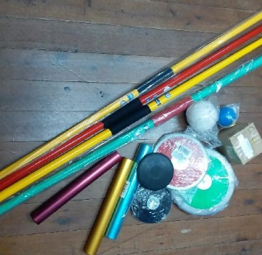
The club could use this offer towards the purchase of equipment.
For example, when 20 of your members purchase their shoes through us we can give the club a voucher for $100 . All your members have to do is make sure that they mention your club on purchase.
We are open Monday through to Saturday. Our aim is to provide the best advice, great service and personally fitted running shoes for all the Family. We would love to bring our mobile shop to your club venue.
Please feel free to call any of our friendly staff to discuss this offer further
Regards from
Robyn
The Runners Shop Randwick
93158711

